As we come to the end of the Fall 2020 semester, we have reached the time to reflect on all the work done in these past couple of months. As we moved through each unit, we have accomplished many of the course objectives introduced to us in the beginning of the semester on our syllabus. Reflecting back on the work and the academic texts we’ve read, not only have my writing and reading abilities for the sciences further developed, but my understanding of information has been reinforced through research papers and collaboration with classmates through discussions in or out of class. This Writing for the Sciences class has presented itself to be relevant to current issues we’re facing this year as a society overall.
In Unit 1 we had the Technical Description assignment which was asking us to describe an object or process and how it works with regard to other processes happening around it. I decided to base the topic of my paper on AirPods and the functionality of them as well as how they actually work. This paper was a bit challenging for me to write because I am accustomed to writing research papers, argumentative, persuasive and informative essays, but I have never been asked to write a paper where I just describe on how something works. I believe that once I got my ideas set straight and found a way on how I wanted to introduce this topic, it was much easier to begin writing. Essentially, I was able to “negotiate my own writing goals and audience expectations regarding conventions of genre, medium, and rhetorical situation.” I figured that the best route for me to take in this technical description was by adding some personal insight as to why this was important to me.

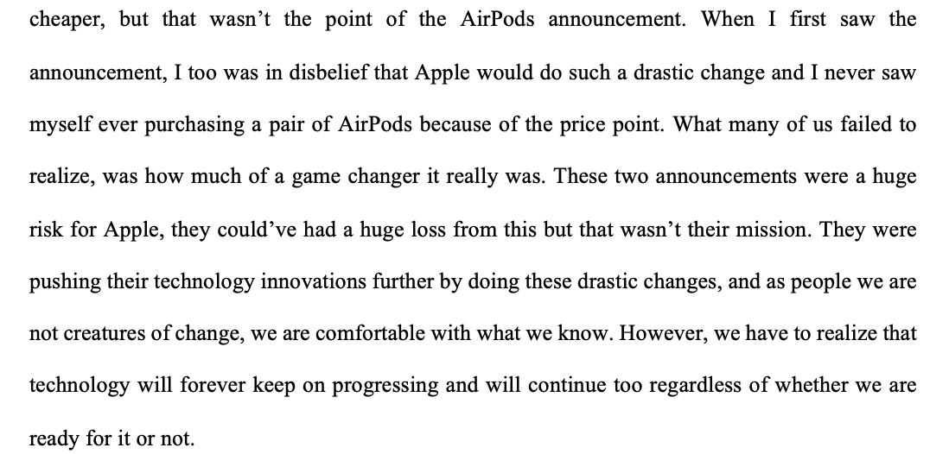
Figure 1: Technical Description
After I included some background information as to why I chose to write about this specific topic, I later included the details of the actual functions of the AirPods and how they work. Since this is the main topic of the technical description, I made sure to not just talk about my personal preferences, I included some insight of that in the beginning and towards the end, but I knew my main focus had to be describing the object.
As we progressed through the Units, as students we became more comfortable with “acknowledging my own and other’s range of linguistic differences as resources and draw on those resources to develop rhetorical sensibility.” When writing the research paper, we had to come up with a topic with our groups that would not only make sense to us, but also be interesting in the long run and make us write an in-depth paper that could include a lot of information. Because of previous classes I’ve taken at CCNY, I have researched the topic previously so I had some knowledge on it, and I then presented my idea to the group. We took it a step further and included much more than I originally anticipated. It made me feel as if we were really working as a team. This research paper really made us touch upon “developing and engaging in the collaborative and social aspects of writing processes.” There were instances where I was reading over a certain section and I felt as if it didn’t flow, so I let my group know that I would be writing a paragraph taking that information and making it flow better. Figure 2 was the introductory paragraph for the method section, and I felt as if I was to say this out loud, it would sound repetitive. I managed to find a way to incorporate the same information but, in a way, where it was presented coherently and uniformed. It was easy to move on from one topic to another without it sounding forced, like a conversation but in writing. Figure 3 was the final paragraph that was included in the final research paper. As a group, we edited the entire paper a couple of times, going through each section to make sure our ideas were presented coherently. I felt as if the most challenging part of this was making our ideas connect with one another since it was different people writing different sections all at once. We had to go back a couple of times to make sure that we included the right information and if we wanted to reference back to a previous section, we had to make sure we understood the information that was used.

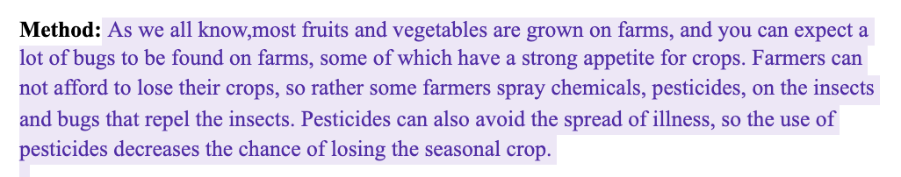
Figure 2: Method Section in the Research Paper

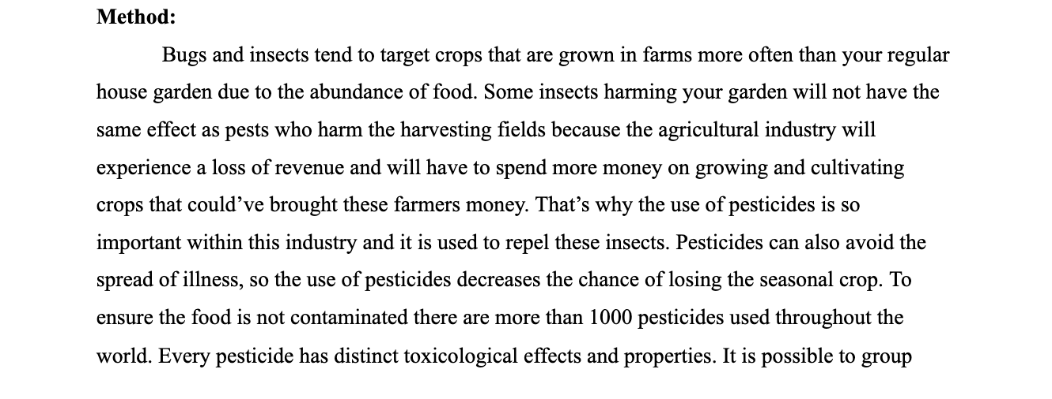
Figure 3: Revised Method Section in the Research Paper.

The research paper was where we each had to “practice using various library resources, online databases, and the Internet to locate sources appropriate to our writing projects.” We had to ask the professor a couple of questions regarding the format of citations when using different articles such as peer reviewed journals, or articles we found on TIME Magazine.
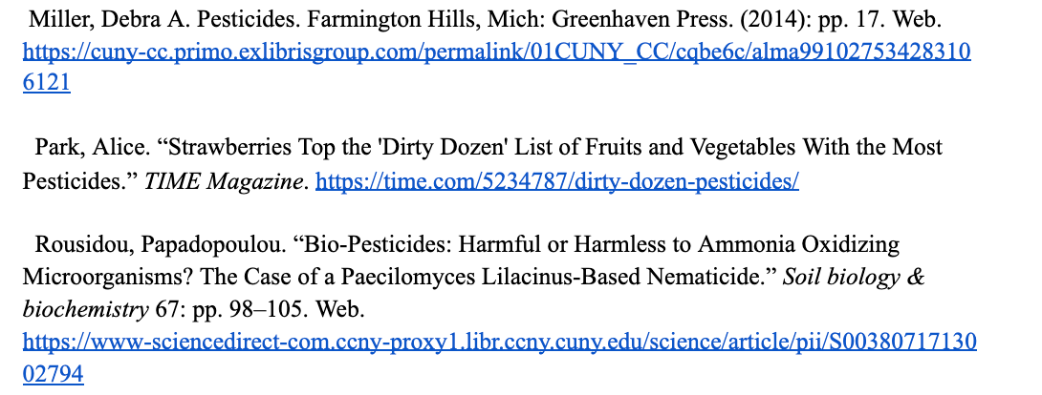
Figure 4: Citations in the Research Paper

These are a couple of examples in which we were asked to find research to back up the claims made in our research paper. I still don’t feel as confident citing citations, I feel as if that is something I would always need to double check with a professor or peers if I have missed anything or wrote it incorrectly. The reason for this is because it really differs as to which article you are trying to cite, and I can get it confused with different forms of citing. This is something I would personally need to work on, and I need to spend more time doing. As for finding research and reading it and applying it, I feel confident doing that in future research papers. Through our use of various different types of sources we all looked through, we were able to “strengthen our source use practices, (including evaluating, integrating, quoting, paraphrasing, summarizing, synthesizing, analyzing, and citing sources.)” When we used paraphrasing and citing direct quotes, we used in text citations to show as to where we got that information from.
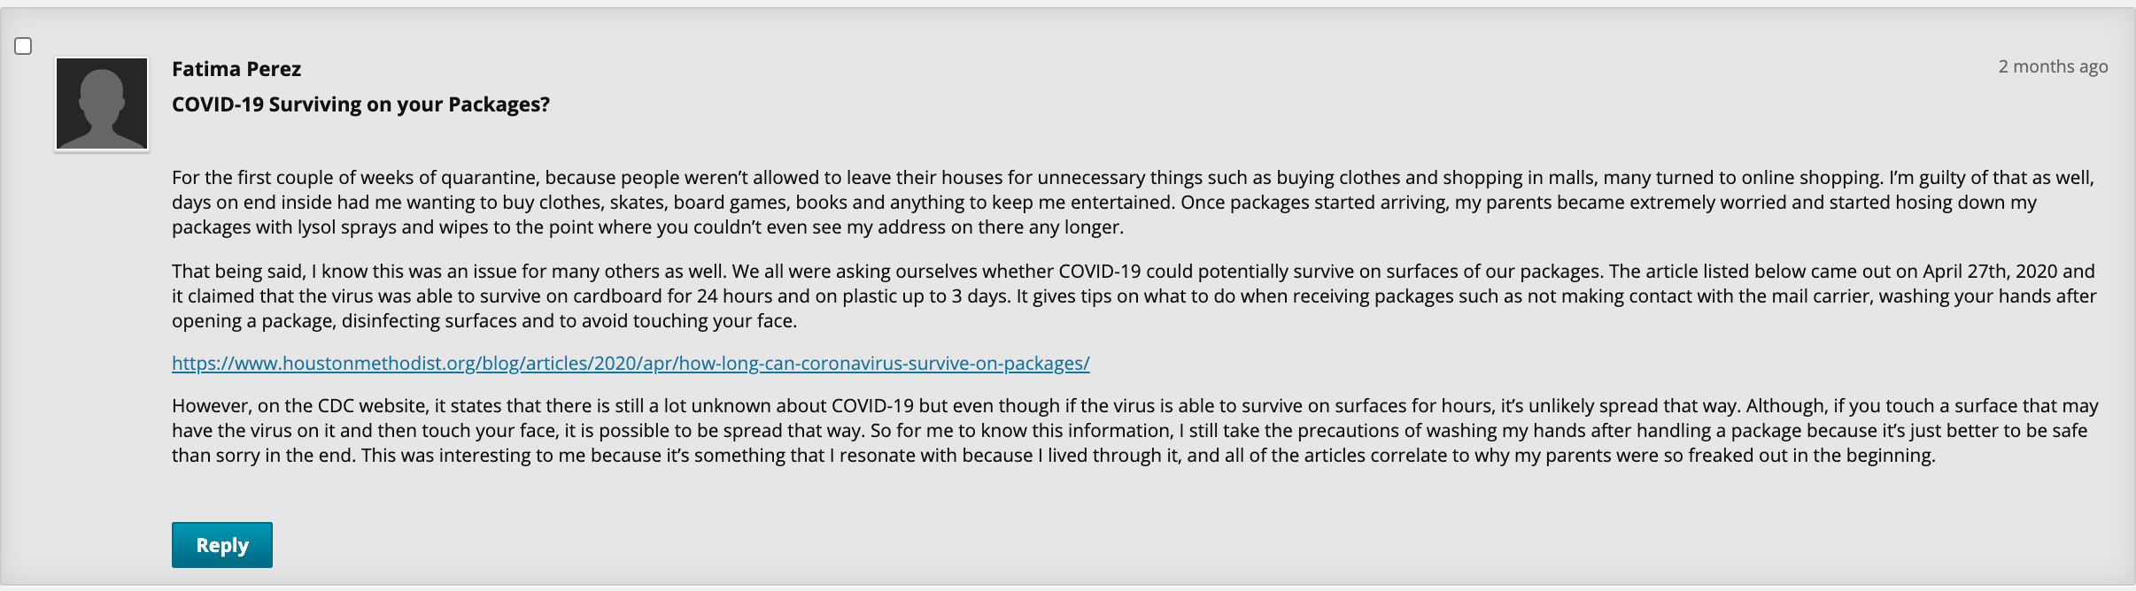

Figure 5:
Throughout all the discussion board posts, I truly felt interested to add on to the conversation. I was able to “formulate a stance and articulate it through my writing,” and people were able to read my stance on points I made, and they also made some comments back to me asking questions or just stating their opinion. Since discussion board posts were weekly, we were able to read and “engage in genre analysis and multimodal composing to explore effective writing across disciplinary contexts and beyond.” Each unit had different topics that we had to read upon, so it wasn’t as if we were reading the same type of literature repeatedly, it varied and it depended on what we were discussing that week.
I felt as if one of the only things I lacked this semester was “enhancing strategies for reading, drafting, revising, and self-assessment,” this semester, only because I depended solely on the comments made on my papers to know whether it was an appropriate paper and if it had the correct structure. I’ve had my moments of doubts when writing some papers, but the instructions for writing it seem clear enough to follow so I managed to do so. Sometimes peers may catch somethings that you wouldn’t have noticed on the paper, so I would’ve liked to have some “peer-review” sessions added before handing in a paper.

