Fatima Perez
Writing for the Sciences
Technical Description
September 22, 2020

Technical Description of Apple AirPods

Apple Airpods when they first were announced didn’t have a positive reaction with the public, in fact many people angry with the announcement. As part of the iPhone 7 event, that was the very first iPhone that did not have a headphone jack. Many were outraged of the price point of the AirPods because we felt as if they were unnecessary and we could get headphones for way cheaper, but that wasn’t the point of the AirPods announcement. When I first saw the announcement, I too was in disbelief that Apple would do such a drastic change and I never saw myself ever purchasing a pair of AirPods because of the price point. What many of us failed to realize, was how much of a game changer it really was. These two announcements were a huge risk for Apple, they could’ve had a huge loss from this but that wasn’t their mission. They were pushing their technology innovations further by doing these drastic changes, and as people we are not creatures of change, we are comfortable with what we know. However, we have to realize that technology will forever keep on progressing and will continue too regardless of whether we are ready for it or not.
Apple introduced the Airpods by saying that up until that point, no one had really taken on the challenge to deliver an audio experience wirelessly between your mobile device and headphones. The AirPods come with a charging case that they are in at all times, and in order to connect them to your phone there is only a one tap set up to get your device connected. All you have to do is open the lid and your phone will receive a notification to press connect, and you are ready to start listening. The Apple Airpods has infrared sensors which is able to detect when each AirPod is in your ear and music will only play when you’re ready to listen. You are also able to access Siri by simply tapping on the AirPod while it’s in your ear, or by saying “Hey Siri”. AirPods provide the convenience of being able to move around freely without the hassle of a wire having to restrain you from doing your daily routine. As for the exterior design, it’s very simple. You are able to see the microphone, the antenna, the dual optical sensors and the labeling of each AirPod from the outside. As for the interior design, this is where it gets more complex. The dual accelerometers and the dual optical sensors work together to sense whether the AirPod is in your ear. As for the cancellation of ambient noise, you can hear minimally the noise from outside however the newer AirPods called the AirPods Pro have a new design in which you can fully cancel out ambient noise as they have a noise cancellation feature.

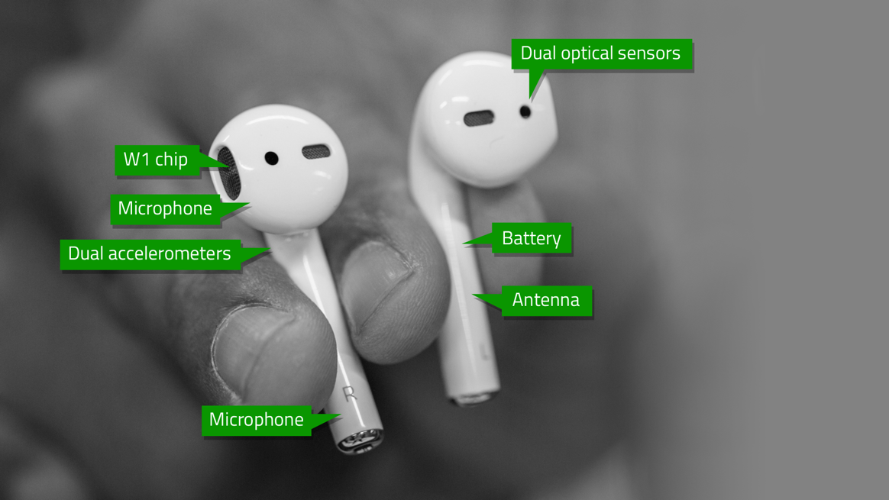
Figure A: Exterior Design of AirPod

AirPods are used for so many things and include many features such as allowing the user to listen to whatever they are listening to without having your phone on hand. It is easy to pair them and have them sync to any of your iOS devices through iCloud making it an easy process to use with your MacBook, iPad, or Apple Watch. In the figure shown below, the AirPods contain a W1 chip which produces high efficiency playback while delivering a consistent and reliable connection. The chip also adds the feature of pausing your music if you remove one of the Airpods from your ear, and it resumes when you wear both. Also, AirPods generally last around 5 hours if you were to wear them consistently for the entire time. Thanks to the W1 chip, AirPods can get 3 hours of charge in 15 minutes and to fully charge them it should only take around 20 minutes. This is one of the reasons why AirPods are so efficient, they last for a long time and don’t take too long to recharge in order to be able to use them right after.
Personally, after buying AirPods for the first-time last year, I felt as if I was late to the trend, and I never really had needed them beforehand, so I got them to try them out and see if it was worth the money. To my surprise, AirPods have made simple tasks such as cleaning the house or washing the dishes enjoyable since I am able to do this without having the hassle of carrying my phone around when I’m vacuuming and not getting the wires wet when I’m washing dishes. When I’m working on my computer, I am able to get up and get something from across the room without having to pause what I’m watching and unplug the headphones from my ear. There’s already been instances where the “Hey Siri” feature comes in handy, for example when I have my phone in my purse but I have my AirPods in my ear, I am easily able to say “Hey Siri call …” and tell her to call my parents to check where they’re at without having to manually do everything. It’s small changes that really made the AirPods worth it through my experience of owning them. For people who have difficulty hearing, AirPods are able to act as hearing aids through a feature called Live Listen. Not many people are too aware of this function, but in my Philosophy lecture in my first semester of college, there was someone in class who had this issue. She was able to make her life a little bit easier through this feature in a classroom with almost 150 students. You simply just place the iPhone near the speaker and you’re able to listen to them from a far distance without having to sit completely in the first row.
As the Apple AirPods were launched, this marked the beginning of manufacturers also stepping up their technology, and even when they decided to get rid of the home button for the iPhone that was a huge deal with the iPhone X. Similarly, many people gave Apple the same response as with the AirPods, but we can see now why Apple takes these risks. The public is not used to drastic changes like those, but as I said, as technology evolves, so will everyone and we will become accustomed to those changes. As you walk around today, you see more and more people taking advantage of the features that the AirPod provides and once you try them out yourself, you’ll see how it makes the little tasks in your life a bit more enjoyable.

Bibliography
Panzarino, Matthew (2017, September 13th). Apple’s AL if by Air”/ Figure A.
https://techcrunch.com/2016/09/13/apples-ai-if-by-air/

